Rotary offers prestigious international scholarships of $30,000 or more for graduate students pursuing careers in fields that support:

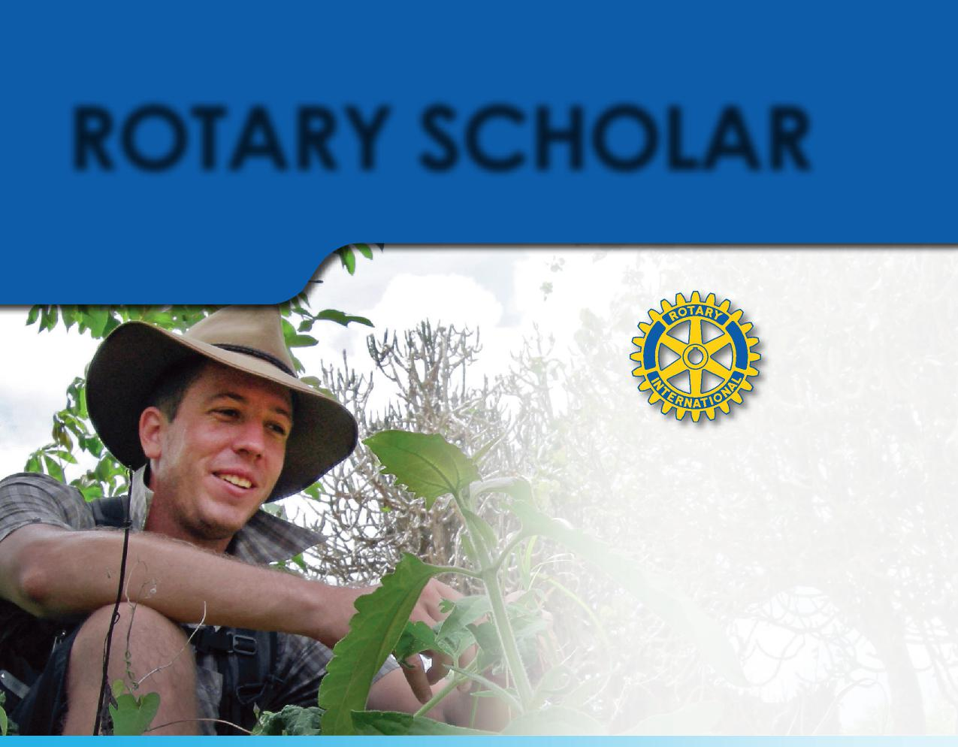
Photo courtesy of Toby Gibson 2006
ROTARY SCHOLAR
Think globally Make a difference Become a leader
BECOME A
Alex Dalley, a Rotary Scholar from Australia, earned an MBA at the Rotterdam School of Management in the Netherlands
“My studies will enable me to build better businesses that link small farmers to local and global food supply chains.”
- Peace and conflict prevention/resolution
- Disease prevention and treatment
- Water and sanitation
- Maternal and child health
- Basic education and literacy
- Economic and community development

Find out more at www.rotary.org or at Rotary District 6220 http://www.ridistrict6220.org/ “Global Grant Scholarship” page; or email jjtvision@charter; call 715-675-9505.
Local Rotary scholarships opportunities may also be available in your area. Ask your local Rotary club.

132-EN—(812)

